Lesson Plan “Mrs Dalloway’s Party” and Mrs Dalloway

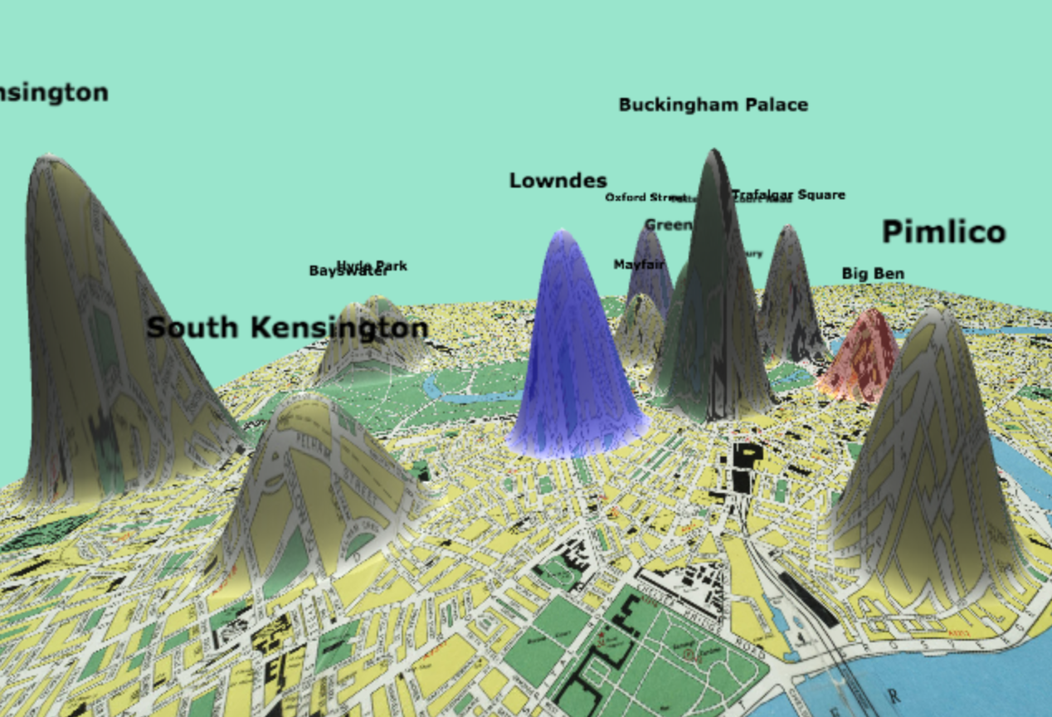

Readings
Woolf, Virginia, 1882-1941. Mrs Dalloway. London: Published by L. & V. Woolf at the Hogarth Press, 1925.
Woolf, Virginia. “Mrs Dalloway's Party: A Short Story Sequence.” London: Hogarth Press, 1973.

Key Points
“Mrs Dalloway’s Party” and Mrs Dalloway create similar, yet distinct, versions of London that in turn inform our understandings of the characters in the two related texts. One way to begin an interrogation of this relationship between place and text in these two works is to use digital mapping methodologies to visualize how different texts construct the places about which they write.

For this class, we will explore the relationships between these texts and the Londons they create by generating and comparing 3D warped maps of the city. We will then use these maps in tandem with our own close readings of the texts to address four broad questions and hopefully develop more granular questions based upon the small group activities.

Guiding Question
How does each text interpret London?
How does Woolf’s London change between the two texts?
Why are these changes significant?
What do these changes tell us about the relationship between the two texts?

Lecture Points
Publication histories of the two texts
Key themes in the text
Significance of where people walk/exist
Significance of what people say and think as well as where they speak and think
Geospatial analysis of modernist texts and Woolf in particular
Model use of the z-axis tool (instructions can be found at http://zaxis.uvic.ca/)

Activity
In small groups, generate two maps: one map of “Mrs Dalloway’s Party” and one map of Mrs Dalloway.
Have each group choose a place warped by at least one of the texts to explore and discuss.
Once a group has chosen a place, have them
1) Identify the passages from both texts associated with this place.
2) Close read these passages and record what questions and observations arise in regard to place, space, and textual difference.
3) Choose one question to explore and discuss in their groups.
4) Be ready to share their question and key points from these initial small group discussions with the class.

Homework
- The small groups research the histories of one warped area of the map.
- Come to class prepared to discuss how their new understandings of the places they chose to study inform their readings of the two texts.

Suggestion for the Next Class
After discussing the relationship between place and text, introduce a discussion of affect and place. Use the sentiment analysis function on the z-axis tool and have students, in their groups from the last class, add to their previous findings a discussion about how and why that place is inscribed with a given sentiment in each text.

